Lincoln City Cultural Center
540 NE Hwy 101, Lincoln City, OR 97367
541-994-9994
www.lincolncityculturalcenter.org
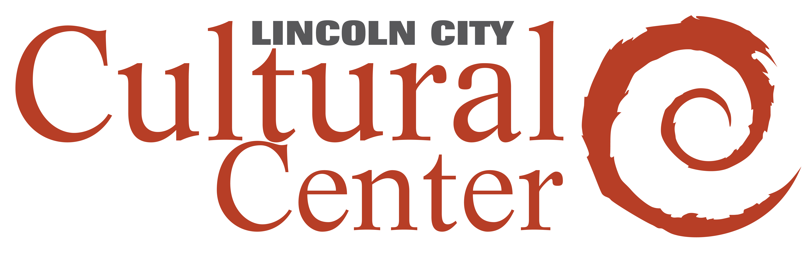

Artist Contract and Inventory Form

Please Print

I, ________________________________________ have volunteered to leave the personal property belonging to me and described below at the premises known as Lincoln City Cultural Center, at 540 NE Hwy 101 in Lincoln City, Oregon, for display from __________________ through ____________________.

I understand I am personally responsible for delivering the property to the premises and picking up such property at the end of the display period. I will not designate any other person to pick up my personal property for me without prior written arrangements with Lincoln City Cultural Center. I understand that the Lincoln City Cultural Center shall provide liability insurance for any damage or theft that may occur while LCCC is in possession of the art work.

Commission for Lincoln City Cultural Center members’ art work is____40%.
(Must be member before show)
Commission for non-members’ work is____ 50%. Initial ________________

Print your name_______________________________________

Email_____________________________________website________________________________________

Address ____________________________________________________ Phone ______________________

Signature ___________________________________________________ Date _______________________

Title Medium Size Value / (NFS) if not for sale

1. __________________________ _____________________ ___________ $ ____________________

2. __________________________ _____________________ ___________ $ ____________________

3. __________________________ _____________________ ___________ $ ____________________

*Personal property and works left at the cultural center over 30 days (without prior arrangement as noted on this form) after their event ends becomes the property of LCCC (Lincoln City Cultural Center) with all proceeds benefiting LCCC.

LCCC Summer Members’ Show
July 9 through August 8, 2021

The Lincoln City Cultural Center has a proud tradition of honoring its member artists with a show during the height of the summer season so that visitors from near and far can see some of the amazing home cooked artwork made by our talented local arts community. This exhibit showcases new artwork exclusively done by LCCC’s current members and is open to a wide variety of styles and mediums.

The Cultural Center would not be here without it’s members…. Thank you to all that support the Lincoln City Cultural Center.
Show dates- July 9- August 8
Opening-in person Opening Reception on Friday, July 9, from 5 to 7 pm
Open to all current members- 2 pieces of art each. Please tag or label all work with name, title and price.
Deliver- On or before Tuesday, July 6 to the Lincoln City Cultural Center between 9 am and 2 pm. You may also drop off work anytime during open hours the week prior to Tuesday the 6th, LCCC is open Thurs- Sun. 10am to 4pm.
Inventory form- Make sure to fill out an artist contract/ inventory form to submit with your work.
Pick up day- Tuesday August 10- pick up your artwork anytime between 9 - 2pm.
Call Krista with any questions- cell 541 992 4292
Or email at artgallery@lincolncity-culturalcenter.org

